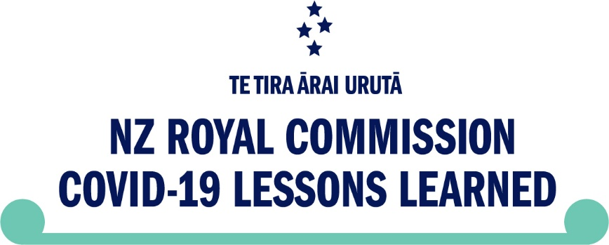

Summary - Royal Commission of Inquiry into COVID-19 Lessons Learned – findings, lessons, and recommendations
This document provides a summary of the work of the Royal Commission of Inquiry into COVID-19 Lessons Learned and the information contained in the Inquiry’s Phase Two report.

What is the Royal Commission of Inquiry into COVID-19 Lessons Learned?
The Royal Commission of Inquiry into COVID-19 Lessons Learned (the Inquiry) was set up by the New Zealand Government in 2022 to review Aotearoa New Zealand’s COVID-19 experience so the country can be more prepared for future pandemics.
The Inquiry happened in two parts - Phase One and Phase Two. Phase One reviewed many aspects of New Zealand’s pandemic experience and published a report in 2024.
Phase Two looked at some new topics and also looked at some of the topics from Phase One in more detail.
The Inquiry looked at New Zealand’s COVID-19 experience and how the Government managed the pandemic. We have considered thousands of documents and have heard directly from a wide range of people and organisations including former ministers and senior public servants, community and advocacy groups, business owners and experts from across New Zealand.
The Inquiry completed its first report in November 2024 and its second report in February 2026. The reports share what we learned about New Zealand’s pandemic experience and also make recommendations for how the Government can prepare for and manage any future pandemics.
You can read both reports on our website: www.covid19inquiry.nz
You can also find a summary of the Phase One report in English, te reo Māori, Samoan, Tongan, Hindi, Simplified Chinese, New Zealand Sign Language, Easy Read, Braille, Audio, and Large Print on the website: https://www.covid19lessons.royalcommission.nz/translations-and-alternate-formats [and https://tinyurl.com/2f86tznc]

Phase Two of the Inquiry
This document provides a summary of what Phase Two of the Inquiry learned about the COVID-19 pandemic in Aotearoa New Zealand and what we recommend the Government does to prepare for and manage any future pandemics.
In Phase Two, we were tasked with learning lessons from the country’s COVID-19 response, to improve our overall pandemic readiness.
We were asked to look at key decisions the Government made in the period from February 2021 to October 2022, including the impacts of those decisions. The specific topics we were asked to look at were:
- vaccine approvals, processes and safety,
- vaccine mandates,
- testing and tracing technology, and
- national and regional lockdowns.
Our report is based on evidence gathered over the past 15 months.

What we found
Overall, we found that Aotearoa New Zealand’s response to the COVID-19 pandemic was well considered and appropriate in light of the information available at that time.
At the same time, we also found areas where we believe the Government’s response could have been strengthened including:
- New Zealand’s overall strategy and settings not always being sufficiently responsive to changing circumstances.
- Some decisions were taken with less information than could have been available – for example, certain mandate decisions.

Vaccine approvals, processes safety
Decision-makers at the time saw vaccinations as a way to protect the New Zealand public from the virus and reduce reliance on other measures like lockdowns.
We found that:
- Vaccines were considered and approved based on sound evidence, and decisions about vaccine approval and safety were robust.
- Potential risks or side effects were monitored based on expert advice and ongoing evidence and experience from New Zealand and overseas.

- Although the Government shared information about the risks with the public they underestimated how much concerns around the safety of the vaccines would grow.

Vaccine mandates
The Government’s use of vaccine mandates was seen as one of the more controversial aspects of the pandemic response.
Some people told us it made them feel safer, particularly if they were at higher risk of being severely impacted by the virus. We also heard from people who said that mandates infringed upon their rights and were harmful.
After considering all the evidence, the Inquiry has concluded that vaccine mandates are a valid intervention that should remain an option for future pandemic responses, but they should be used carefully and monitored and reviewed frequently against clear criteria.
Decisions to end mandates should be actioned quickly, given their impact on individual rights.

Testing and tracing technologies
Testing for COVID-19 was a vital component of New Zealand’s health response, from the outset.
It was critical to identifying and managing outbreaks.
For most of 2021, there was reliance on Polymerase Chain Reaction (PCR) tests due to their accuracy, but the testing system became overwhelmed in early 2022 due to the Delta outbreak.
The Government’s slow approval of alternative tests and limits on importing tests meant some people struggled to access reliable tests when needed.
Overall, the Inquiry found key decisions on testing technologies were well-informed on technical matters but not on longer-term strategic choices.

Lockdowns
In August 2021, a national lockdown was implemented to minimise the spread of the Delta variant. The lockdown was extended for Auckland, Northland and Waikato based on advice from public health experts. This had significant consequences for communities and businesses inside the lockdown area, and beyond.
The Inquiry found more regular reviews of the strategy could have supported an earlier shift out of the lockdown when it became clear that eliminating the virus was unlikely.
However, ending the lockdown too early or not having a lockdown at all would also have had harmful economic and social impacts.
Having more data on likely social and economic impacts would have strengthened decision-making.
After reviewing the evidence, we consider that, for the most part, decision-making was sufficiently informed and reasonably balanced.

Hearing from the public – pandemic perspectives report
An important part of the work of the Inquiry was hearing from people who experienced the pandemic in New Zealand. We received more than 31,000 public written submissions from the public, and we also met with organisations and communities around the country to hear what they had to say.
This is what we heard:

Vaccine, Approvals, Processes and Safety
- Some people said they were worried about the safety of the COVID-19 vaccine and described feeling unsupported after suffering from injuries they linked to the vaccine.
- People said they were generally happy with how easy it was to get vaccinated.

Vaccine mandates
- Vaccine mandates were the most discussed topic in the submissions. Feelings about vaccine mandates were mixed. Some people said that vaccine mandates divided people and caused a lot of financial stress, and that it should have been easier for people to opt out of getting a vaccine. Others said they felt safe knowing that most people were vaccinated.

Lockdowns
- People shared the difficult experiences they had during lockdowns, like being separated from loved ones or losing their jobs. However, many people also said they felt lockdowns helped stop the pandemic and they appreciated the support the Government gave people during the lockdowns.
- People often criticised the length and basis of restrictions, particularly the Auckland, Northland and Waikato lockdowns of 2021.

Testing, tracing technologies and other public health materials
- People discussed a range of negative impacts of masks, including poor treatment of mask-exempt people, physical discomfort, difficulties with wearing a mask as well as other social issues.
- People were happy that Rapid Antigen Tests (RATs) were free, although many people wanted to have access to tests earlier.

Communication and information
- Some people felt that the Government communicated very well, while others felt that the Government’s communication made people more scared.
- Some people shared that they thought the pandemic was a government conspiracy and was made-up.

Māori, iwi and Pacific perspectives
- Māori and Pacific peoples shared how hard it was to not be able to follow cultural traditions because of pandemic rules.
- Many people shared how supportive local iwi and Pacific groups were during the pandemic.

Sectoral and Regional engagements
- When talking to organisations, we heard that the Government started out working well with organisations and communities but that this did not always continue. They also wanted to see some of the new ways of doing things that started during the pandemic keep going even after the pandemic.
- People in different areas of the country said each area faced different challenges and had different needs.

The overall response
- In general, people had mixed feelings about the Government’s management of the pandemic. Many people felt safe and that the Government did a good job, while others felt that the Government had too much control over people’s lives. People who did not like the Government’s response told us they no longer trusted the Government.

What we recommend
The Inquiry has provided recommendations to the Government on how they can prepare for and manage future pandemics.

The Inquiry recommends:
- putting systems in place to support good decision-making, including a strategic function to oversee work across government, and regular reviews of decisions during a pandemic.
- establishing dedicated legislation that sets out the special powers available to government in a pandemic. It should define the scope of those powers and provide safeguards for individual freedoms, when those powers are invoked.
- preparing for the economic impacts of a pandemic, by building a fiscal buffer, and plans for support for individuals, businesses, and the economy.
- creating and maintaining a practical guide for decision-makers facing a pandemic.
- improving understanding about the social impacts of the COVID-19 response, and how to communicate effectively during a pandemic.
The full findings and complete list of recommendations can be found on the Inquiry’s website - www.covid19inquiry.nz

What happens now
The Inquiry is now finished, and both the Phase One and Phase Two reports have been given to the Government.
It is now up to the Government to decide what recommendations they will work on to help Aotearoa New Zealand prepare for future pandemics.
All the information the Inquiry collected will be stored at Archives New Zealand. Some of this information can be looked at by the public, while other information will be kept private.
If you have a question about the work of the Inquiry, you can email inquiryintocovid-19lessons@dia.govt.nz
For more information about the work of the Inquiry or to read our reports, please visit: www.covid19inquiry.nz
End of information | Summary - Royal Commission of Inquiry into COVID-19 Lessons Learned – findings, lessons, and recommendations
This Large Print document is adapted by Blind Citizens NZ from the standard document provided by Royal Commission of Inquiry into COVID-19 Lessons Learned

